Team name: Project4

Scrum Master: Marc

Date:18 April 2019

|  |  |  |  |
| --- | --- | --- | --- |
| **Team Member** | **What did you do since the last scrum?** | **What do you plan to do before the next scrum?** | **What obstacles do you have?** |
| Jeffrey | refactoring node.js and merging with postgressql | integrate database to server with Brandon | Finishing before end of the semester |
| Marc | Unit Testing | More Unit Testing  CSS, database | Finding time |
| Jazlyn | CSS,  Navigation  HTML  updating forms | updating CSS, HTML, Navigation / connection to DB | Having enough time to finish everything |
| Brandon | refactoring node.js and merging with postgressql | Work on DB and DB calls from server. Refactor and update tables | Having enough time to finish everything |

Burndown:

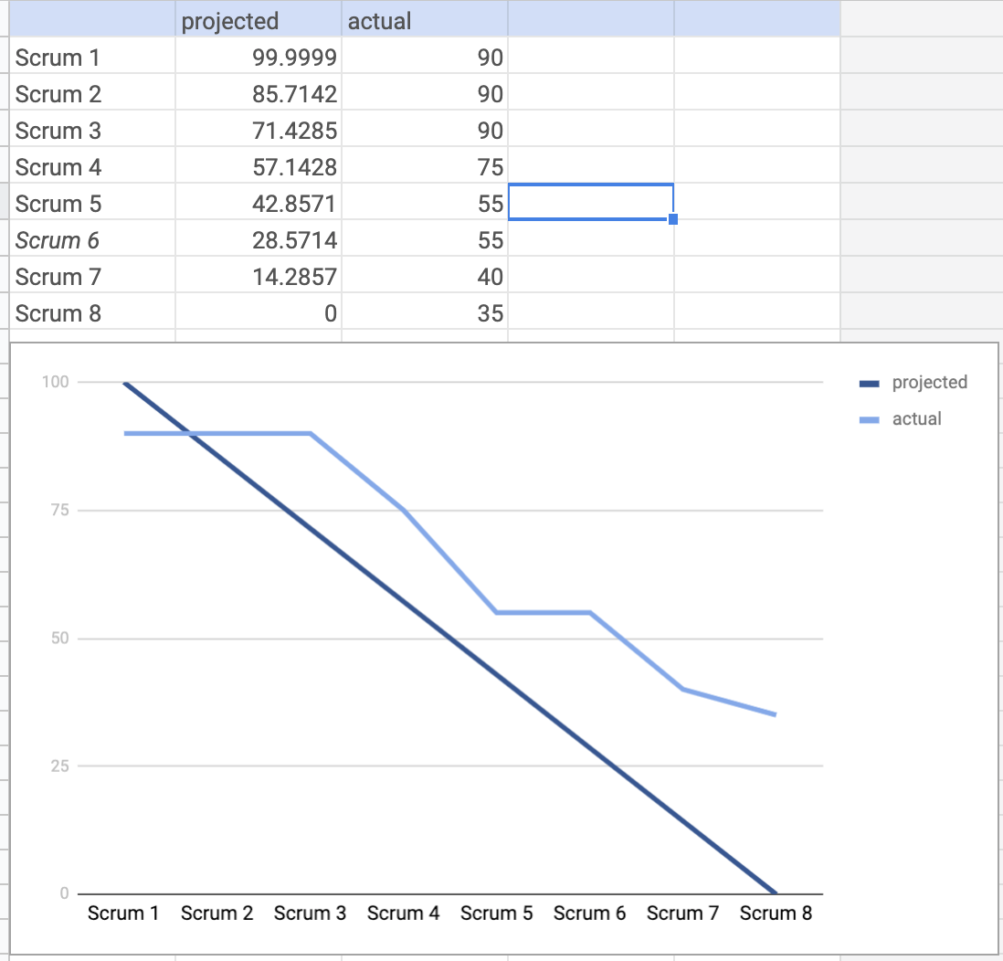

Screenshot of your task board:

